**Tool wear simulation visualizations**

Tool wear significantly impacts the efficiency and cost-effectiveness of machining operations. This project explores the relationship between machining parameters (feed rate, spindle speed, and depth of cut) and tool wear through simulated data, offering valuable insights into optimization and maintenance strategies.

**Visualization 1: Tool Wear Over Operations**

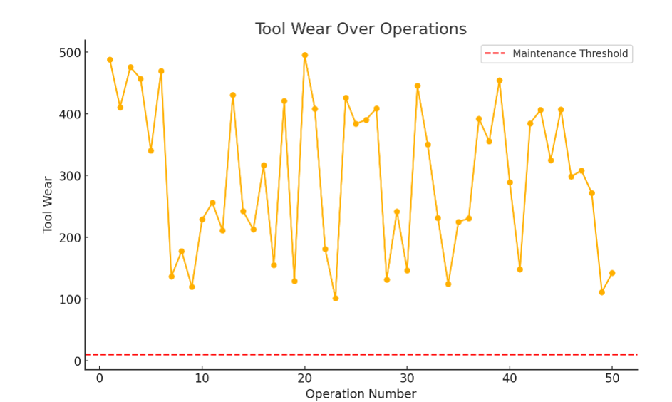

The visualization illustrates tool wear over successive operations, with the red dashed line marking the maintenance threshold. Each point represents the simulated tool wear for a given operation

**Visualization 2: Distribution of Tool Wear**

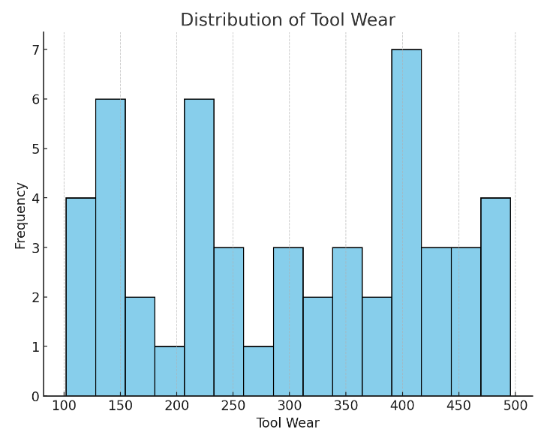

The histogram illustrates the frequency of different tool wear values, highlighting the variability in wear across operations.

**Visualization 3: Tool Wear vs. Feed Rate**

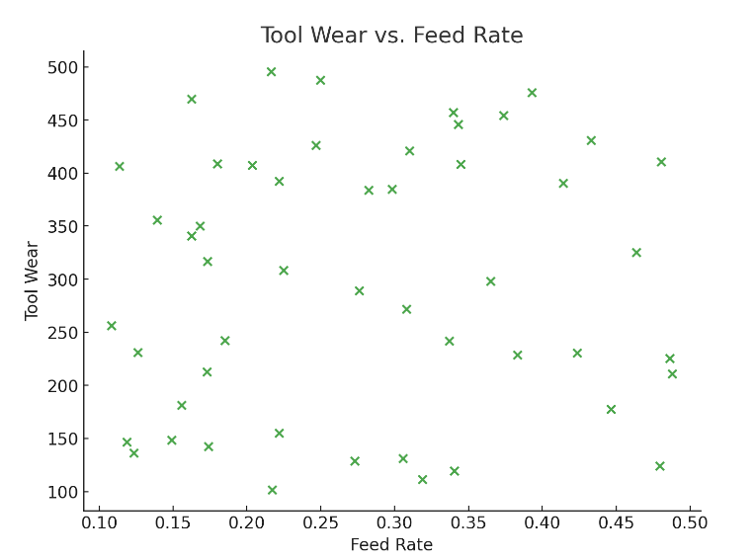

The scatter plot reveals how feed rate influences tool wear, with trends indicating the potential for parameter adjustment to minimize wear.

**Visualization 4: Tool Wear vs. Spindle Speed**

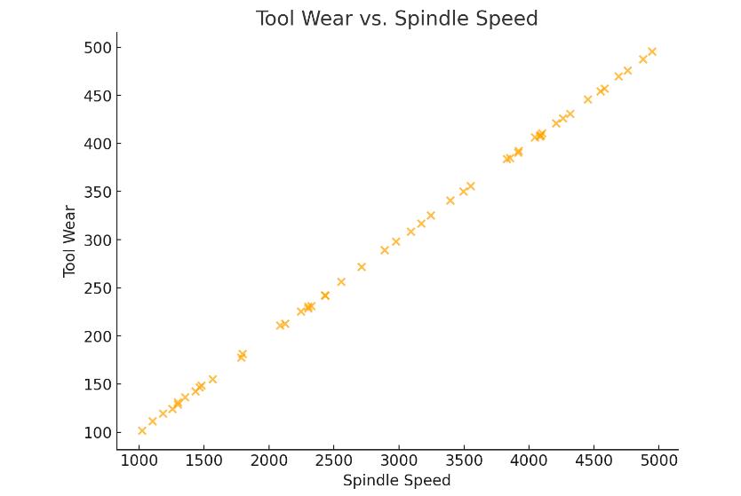

The scatter plot examines the relationship between spindle speed and tool wear, showing how higher or lower speeds can impact tool longevity.

**Visualization 5: Tool Wear vs. Depth of Cut**

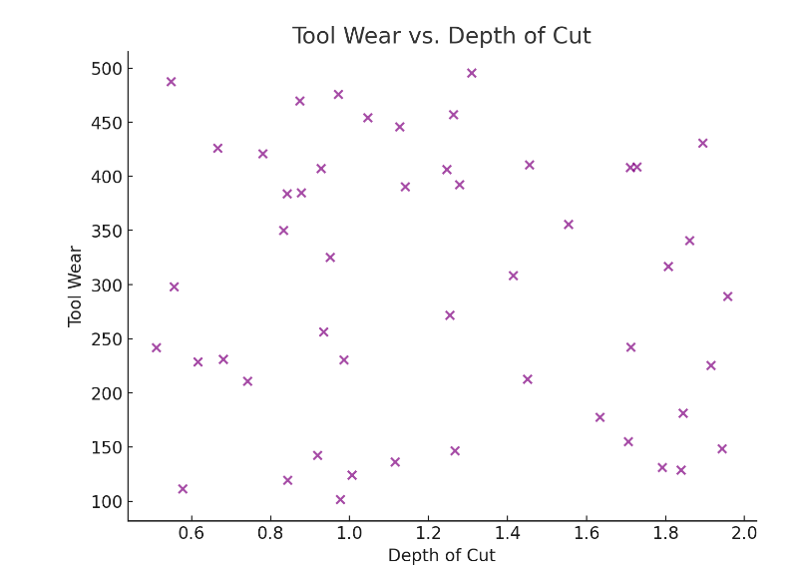

This plot demonstrates the effect of depth of cut on tool wear, identifying thresholds where wear increases significantly.

**Visualization 6: Cumulative Tool Wear Over Operations**

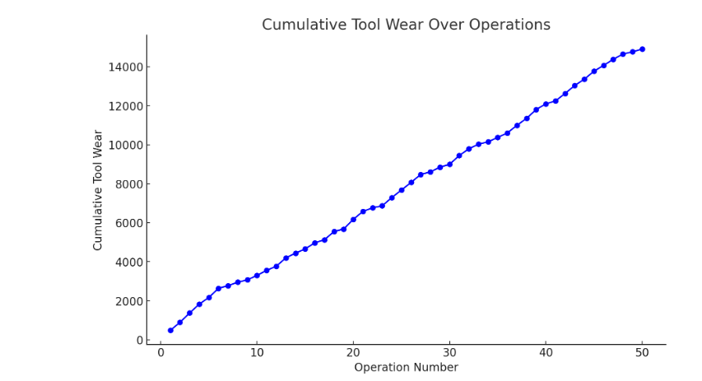

The line plot tracks cumulative tool wear, illustrating the progressive nature of wear and the importance of monitoring trend